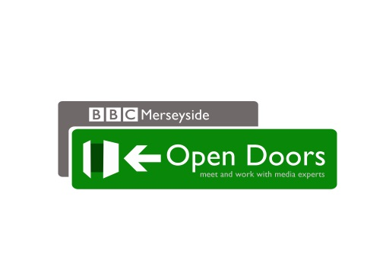 | WE CAN HELP YOU  GET YOUR  COMMUNITY NOTICED
Help us tell others what life is like in your community. Open Doors can show you how to get your community group - and stories that you think matter – noticed.

Name of Organisation:
Address:
Tel:
Name of Contact:
Role within Organisation:
Mobile Number:
Email & Web Address:
Registered Charity Number* (if applicable):
Date of application:

- Membership – please provide some background information about the organisation and its role within the community

- Location – please tell us where you are based, the facilities you offer and how you actively engage with your local community:

*If you are not a registered charity please attach a copy of your constitution, or set of rules to this application.

- Audience – please tell us about the background, age and profile of the people your organisation supports:

- Quality – please tell us about your story idea, outlining how it demonstrates the activities of the group and why you think it will be of interest to the community served by the BBC local radio station you are applying to:

- Please provide any additional details that you feel will support your application:

Completed by: Date:

Please complete and return your form to mairead.smyth@bbc.co.uk. If you have any questions you would like to ask before submission, please send us an email at the relevant above address and we will respond ASAP.

The BBC will only use your personal details for the purposes of administering this project. We will not publish your personal information or provide it to anyone not connected with this project without your permission. Please visit the BBC's Privacy & Cookies Policy (http://www.bbc.co.uk/privacy/)for more information.

