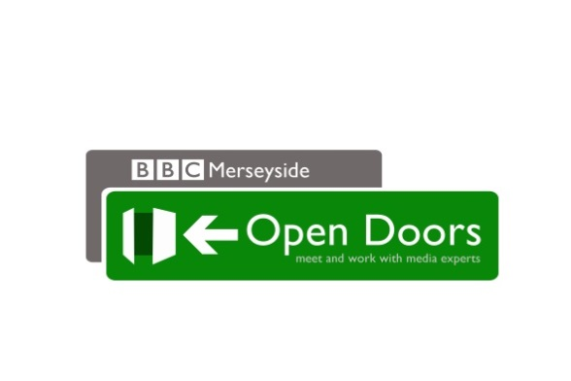

We can help you get your community noticed

Could you help us tell others what life is like in your community? We want to meet the everyday people that make it tick.
In return, Open Doors can show you how to get the stories that matter to you noticed. If you are part of a community group or charity, it can also let others see what you do. BBC Radio Merseyside wants to talk to groups that work in diverse areas. Everyday stories about different communities can improve understanding and raise awareness about the people and projects that support them.
Open Doors will let you see the media in action and discover how to work with it to your advantage. It offers useful contacts for your group and an opportunity to share stories about under-represented communities. The one off Open Doors events will take place on Monday 15th May 2017 10.00 – 17.00.
Places are strictly limited, so if you would like more information or want to take part, just email or call to request an application form and guidance notes.
Applications close at midnight 28th April 2017.
To apply, please email Mairead Smyth who will send you an application form - mairead.smyth@bbc.co.uk . Please title it ‘Application – Open Doors’. Or call 0151 708 6161 if you need to pick up a form.
We will be in touch after the closing date to notify you of the outcome of your application.

Who can apply?
We welcome applications from charities and community groups in the editorial area of BBC Radio Merseyside.
These organisations should work with disadvantaged, diverse or socially excluded communities.
If your group would like an insight into bringing story ideas to life with the help of the BBC, please apply to take part in BBC Merseyside Open Doors.

How we assess applications
The following criteria will be used to assess each application:
Membership – Applications will be considered from not-for-profit charity, community or voluntary organisations.
Location – Applications will be considered from groups anywhere in Merseyside and Cheshire West & Chester.
Audience – Applications from those directly working with disadvantaged, diverse or socially excluded communities will be given priority. Other applications will be considered, however priority will be given to those connecting our staff and audiences with those we’ve identified as hard to reach.
Quality – Applications should clearly demonstrate how the group’s proposed story idea will be of interest to the community that the BBC local radio station serves and its activities with under-represented communities.

Conditions
You must be over 18 (no upper age limit), live in the editorial area of BBC Radio Merseyside and be actively involved in a community group serving diverse communities. Applications are limited to two people per group.
You must be available to attend BBC Radio Merseyside for the whole day on Monday 15th May 10.00 – 17.00

What happens next? We will select a group of delegates to take part in the Open Doors event based on the information supplied in the applications. We will contact you to let you know if you have been selected or not. The BBC’s decision is final.
