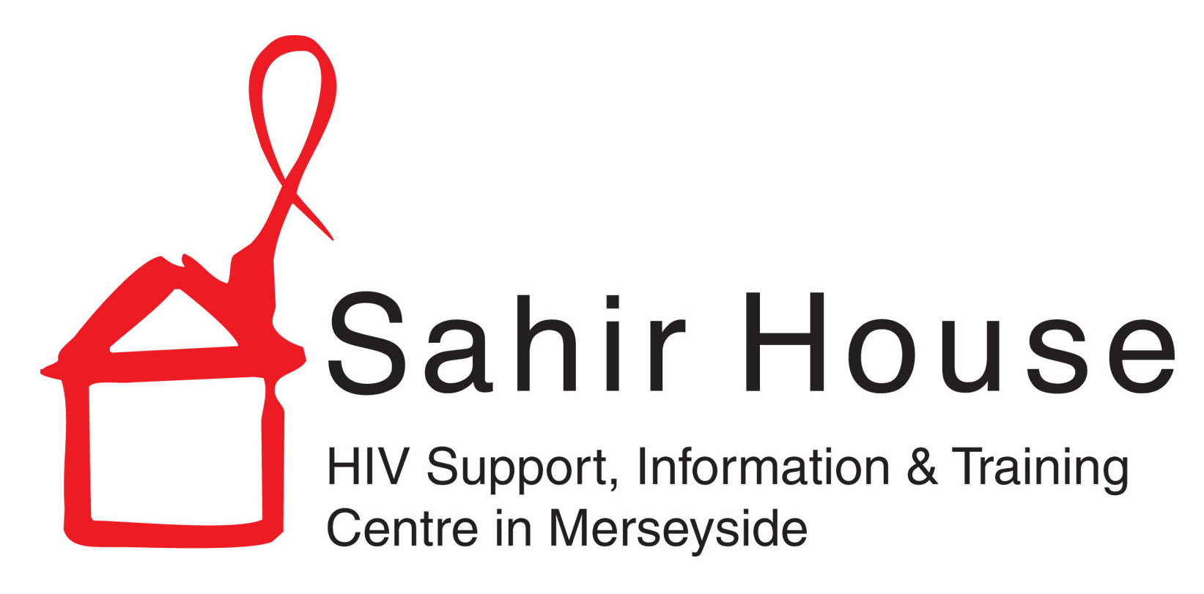
Sahir House is recruiting

Sahir House (registered charity 1077327) is an award winning organisation has been delivering support to people living with, or affected by, HIV for over 30 years. It also provides a range of health promotion and training interventions to professionals and the wider public.

After seeing a period of restructure the charity is now in a secure position going forward. Having secured significant contracts, our funding is now more secure for the next few years. The Board and Senior Management Team want to take this opportunity to maximise the utilisation of current resources and prepare the team for future growth.

This has created an opportunity for a highly motivated self-starter to lead a short term project to address these issues. The Charity is therefore seeking to employ someone on a 6 month contract. The new post will identify opportunities to enable Sahir House to understand its processes and resources required to deliver each service it provides. With this clarity Sahir House can become more sustainable, resilient, and ready for growth.

Business Analyst (Cost and Growth)
We are offering a 6 month fixed term contract, at an annual equivalent salary of £28,203 (or £2,350 per month before tax and deductions) for a skilled analyst. The successful applicant will

- Map the organisation’s current funding and activities
- Analyse cost and effectiveness of activities
- Design tools to ensure the future effectiveness of key business functions like costing of services and project management of activities

Hence we are looking for someone who:
- Has graduate/postgraduate knowledge in business/finance
- Able to analyse complex data, including accounts
- Able to communicate technical information in a simple manner
- Some prior knowledge of working in the voluntary sector would be useful (not essential)

The post is subject to probationary period, satisfactory references and DBS check. Mandatory staff induction training required.

Closing date for signed applications forms: 5pm Tuesday 4th July
Interviews will be held: at some point during the week of 10th July

Download an application pack from our website here
Sahir House is an equal opportunities employer and welcomes applications from all sections of the community. We especially welcome applications from groups which reflect Sahir House service user groups – HIV positive people (and other disabled people), Lesbian, Gay, Bisexual and Transgender people, people from Black and Minority Ethnic groups and refugee communities.

Sahir House:
info@sahir.uk.com Tel: 0151 237 3989 151 Dale Street, 2nd floor, Liverpool, L2 2AH
website: www.sahir.org.uk twitter: @sahirhouse facebook: Sahir House

